PRUNING HYDRANGEAS
Joan Epler

Since there are so many different kinds of hydrangeas, it is often difficult to know when to prune them. They can be divided into two categories: those that bloom on old wood and those that bloom on new wood. Some general things to keep in mind. Hydrangeas really don’t need pruning at all unless size is an issue in the garden. Some general things that apply to both groups: remove spent flowers as they fade by pruning to the 1st or 2nd node below the bloom, remove dead canes in early spring. If necessary for appearance remove 1/3 of the oldest living canes.
HYDRANGEAS THAT BLOOM ON OLD WOOD
The buds for the following year’s bloom season are formed after flowering during the summer so the stems should be pruned right after the blooms fade. This will give the plant more time to form buds for the following season. Do not prune these to the ground.
Hydrangea macrophylla or Big Leaf hydrangeas, have leaves that are 4” - 8” wide and long. These shrubs range from 5’ -10’ tall and 10’ wide. Flowering is from summer to autumn. They are the mop heads, the flowers or which are big, round balls 4”-10” in diameter, and lace cap hydrangeas. They come in pink (red), blue, or white and color can be changed by modifying the acidity of the soil. An example is Endless Summer.
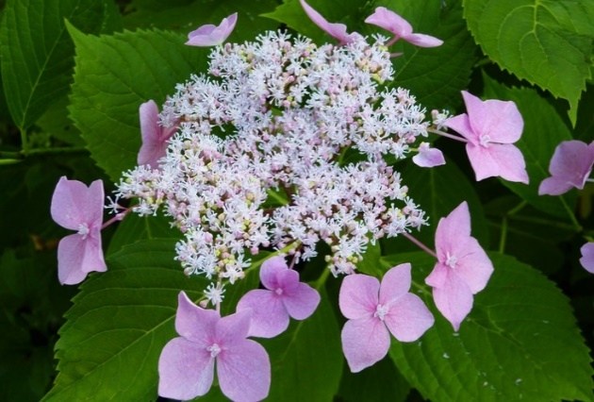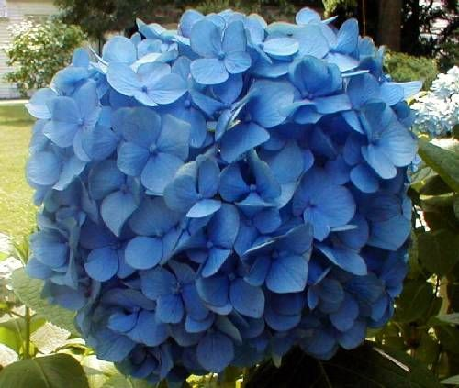
Lace cap Mop head
Hydrangea serrata, is considered by many botanists to be a variation of macrophylla, but by others to be its own species. It is a smaller version of macrophylla and has smaller, lace cap flowers. Typically they range from 2’ – 4’ wide and tall and bloom from June to August. The name comes from the serrated leaves which can be made into a sweet tea. An example is Tuff Stuff. 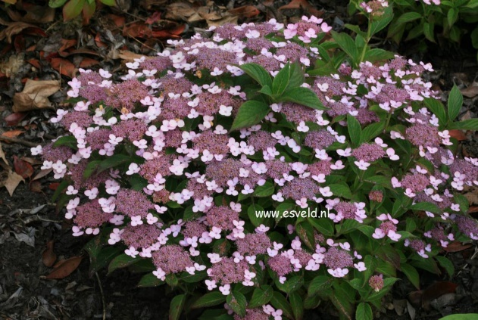
Hydrangea serrata

Oak leaf hydrangeas, Hydrangea quercifolia, have leaves reminiscent of oak tree leaves and have large, panicle shaped blooms. They are large shrubs, typically 6’ – 8’ tall and broad, blooming from May through July.
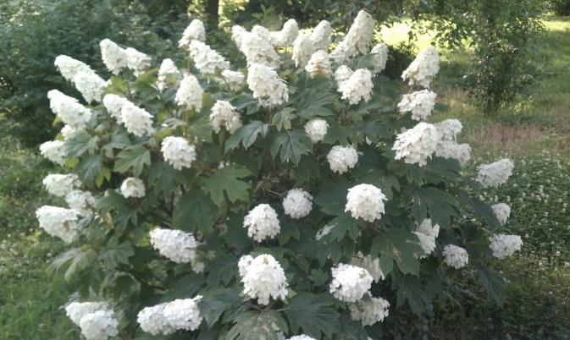
Hydrangea quercifolia

HYDRANGEAS THAT BLOOM ON NEW WOOD
These species should be cut back in late winter before new growth begins and can be cut back to the ground.
The flowers of Hydrangea arborescens, also known as native or wild hydrangea, will be much larger if cut to the ground. If you do not wish to have a floppy, old garden appearance, cut back the stems to about a foot so the old stem can support the new stem. These plants bloom from June to September and have white, mop head, flowers. They get 3’ – 6’ tall and wide. They are native to our region. Examples are Annabelle, Incrediball, and Invincibelle. The Native Americans and early settlers used the root to treat kidney and bladder stones. The bark, leaves, and flower buds are poisonous.
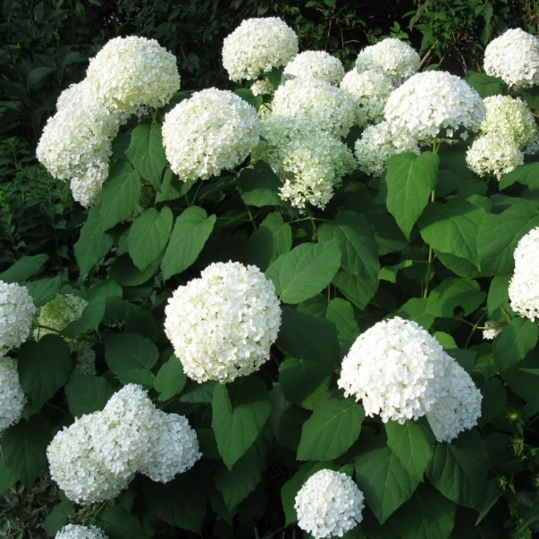
Hydrangea arborescens
Hydreangea paniculata, also known as Pee Gee Hydrangea, have large, 6”- 8” sharply pointed terminal conical panicles and creamy white flowers. Some cultivars may have pink in the blooms. Flowering is from July to September. They are very winter hardy. The shrub is large, 8’ – 15’ high and 6’ – 12’ wide. Thinning these shrubs to 5 – 10 stems will result in larger blooms. The leaves are sometimes smoked for their intoxicating effect but the plant contains cyanide and there is the danger of death. Examples are Limelight and Pinky Winky.
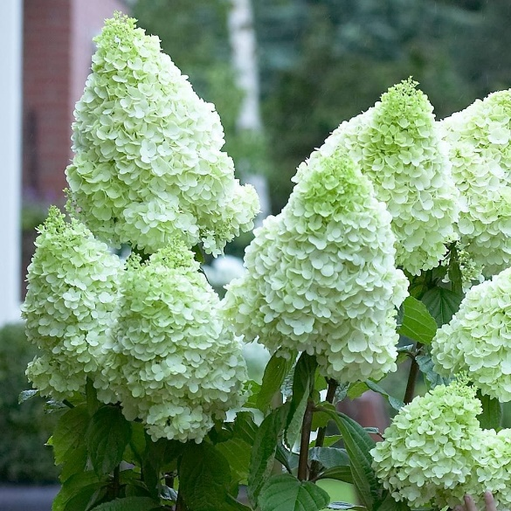
Hydrangea paniculata

References: Missouri Botanical Gardens, Wikipedia, Lady Bird Johnson Wildflower Center, Proven Winners, North Carolina State Extension, Wayside Gardens

